Chapter 6

Electrical Transport Mechanism in the Main Junction of CdTe/CdS Solar Cells

Introduction
In this Chapter an experimental study of the current transport mechanism in three different kinds of CdTe-based cells is presented. The materials that were compared were: a) CSS-CdTe/CdS, b) MOCVD-CdTe/CdS and c) MOCVD-CdTe/CdZnS, this set allowing both the influence of growth method and the type of window layer to be compared.
Current transport phenomena in p-n junctions have been reviewed in Chapter 3, along with the experimental methods used to distinguish them (see Table 2.1). In this Chapter information was extracted from J-V curves and also from their temperature dependence. Where appropriate, the light dependence of the J-V behaviour was measured and interpreted. In particular, the new light-dependant method of determining the diode factor from relative light intensity measurements (equation 2.38) was used.
The current transport behaviour was investigated for each sample under the following conditions:
- forward bias in the dark (Section 6.3.2)
- forward bias in the light (Section 6.3.3)
- reverse bias in the dark (Section 6.3.4).
Details of the sample fabrication and the data collection are given in Section 6.2 and conclusions are drawn in Section 6.4.

Experimental

Fabrication of the samples
Three different samples have been fabricated in order to study the carrier transport mechanisms. Samples number 254 and 305 were fabricated in Bangor University using MOCVD (for more details about the technique see Section 3.2.4) whereas the third one (number 290) was fabricated by CSS in our lab. summarises the structures of these devices, see text below for more details.

Sample number | Substrate | Window  (growth technique) | Absorber  (growth technique) | N-P etch | Contact size
290 | FTO | CdS (CSS) | CdTe (CSS) | Yes | Au 2 mm diameter dot
254 | ITO | CdS (MOCVD) | CdTe:As⁺/CdTe:As (MOCVD) | No | Au 2 mm diameter dot
305 | ITO | CdZnS (MOCVD) | CdTe:As⁺/CdTe:As (MOCVD) | No | Au 5×5 mm square

Table ‎6.1: Description of the main layers in each device investigated in this Chapter.

Sample 290 was fabricated by the CSS technique. A 300 nm thick CdS film was deposited on Pilkington TEC 8 glass at a source temperature of ~ 650°C in O₂ ambient with a pressure of ~ 1 torr . Next, the CdS film was in-situ annealed at 400°C in 3 torr of H₂ prior to the CdTe growth. CdTe was grown under a pressure of 100 torr of N₂ and using a source temperature of about 605°C. The deposition time for CdTe was 45 minutes which resulted in a 8 µm thick films. A 200 nm thick CdCl₂ film was thermally evaporated on the back surface of the cell at a pressure of ~ 10⁻⁵ torr. The device was then annealed in air at 400°C for 20 minutes.
The structure of sample 305 was as follows: CdTe:As⁺(250nm)/CdTe:As(2um)/CdZnS(240nm)/ITO followed by an in-
situ CdCl₂ treatment. Sample 254 comprises: CdTe:As⁺(250nm)/CdTe:As(2um)/CdS(240nm)/ITO followed by the same
CdCl₂ treatment. The only difference in the structure between these two samples was the window layer. The aim of using CdZnS as a window layer is to allow more photons reach the CdTe, as CdZnS has higher band gap in comparison with that of the CdS, see for example references [1-3].
For both samples, a layer of the CdTe:As⁺ was introduced between the CdTe and the back contact to improve the back contact performance [4]. The role and the effect of this layer on the performance of the back contact are discussed in Chapter 7.
All samples were contacted with Au in this lab. Sample 290 was N-P etched for 10 seconds before applying a matrix of 2 mm dot contacts. However, samples 254 and 305 were not etched as they had the CdTe:As⁺ layer on the back surface. Sample 254 had the same contacts as sample 209 whereas sample 305 had 5×5 mm square contacts of instead.

Collecting data
In order to record J-V-T characteristics for these devices, each sample was mounted in the cryostat subsequent to connecting the Au contacts with fine cupper wires using conductive carbon paste (for more details about the experimental setup see Section 4.4.2). The temperature of the samples varied from 300 K to 200 K with a step of 10 K. At each temperature, the J-V data were recorded under illumination of: 0 % (dark), 10 %, 20 %, 50 %, 79 % and 100 % of the intensity of the AM1.5 simulator having a nominal intensity of 1000 Wm⁻². 201 data points were recorded for each J-V run. The data were fed to Origin 8 in order to plot and analyze all the J-V curves.
The current transport mechanism for each device was investigated under three different conditions: forward bias in dark, forward bias under light and reverse bias in dark.
Although the V range varied from -1 V to +1 V during recording J-V-T characteristics, only the range ~ - 0.3 V to - 0.9 V was considered in the study to avoid: a) possible break-down at high V, and b) noise in I values at low V since they are extremely small (especially at low T).

Results and Discussion

Introduction
The results are divided into three parts based on the experimental conditions under which the data were collected: forward bias in dark (Section 6.3.2), forward bias under light (Section 6.3.3) and reverse bias in dark (Section 6.3.4). The reason of excluding the reverse bias data under light from this work is mentioned in Section 5.4.

The dark measurement in forward bias
By using the slope method (which is explained in Section 2.4f), the ideality factor n and the saturation current I₀ were calculated and the results are summarized in Table ‎6.2 for all samples.

Sample 290  CSS  CdS window |  | Sample 254  MOCVD  CdS window |  |  | Sample 305  MOCVD  CdZnS window
T (K) | I₀ (A) |  | n | I₀ (A) |  | n | I₀ (A) |  | n
300 | 1.4E-11 |  | 1.7 | 6.9E-12 |  | 1.5 | 2.6E-9 |  | 2.1
290 | 1.1E-11 |  | 1.8 | 2.8E-12 |  | 1.5 | 1.2E-9 |  | 2.1
280 | 5.6E-12 |  | 1.8 | 1.4E-12 |  | 1.5 | 4.2E-10 |  | 2.1
270 | 3.1E-12 |  | 1.9 | 4.7E-13 |  | 1.6 | 1.4E-10 |  | 2.1
260 | 1.3E-12 |  | 2 | 1.2E-13 |  | 1.6 | 4.1E-11 |  | 2.1
250 | 7.1E-13 |  | 2 | 8.8E-14 |  | 1.7 | 9.9E-12 |  | 2
240 | 4.4E-13 |  | 2.1 | 3.8E-14 |  | 1.7 | 3.1E-12 |  | 2
230 | 2.5E-13 |  | 2.2 | 1.4E-14 |  | 1.8 | 1.4E-12 |  | 2.1
220 | 1.4E-13 |  | 2.4 | 4.8E-15 |  | 1.8 | 3.6E-13 |  | 2.1
210 | 8.1E-14 |  | 2.5 | 1.9E-15 |  | 1.9 | 1.3E-13 |  | 2.1
200 | 3.5E-14 |  | 2.7 | 5.4E-16 |  | 2 | 2.8E-14 |  | 2.2

Table ‎6.2: The values of the ideality factor n and the saturation current I₀ for all samples studied in this Chapter, as a function of temperature.

a) Samples 290 and 254 (with CdS window layer)
The J-V-T data obtained from samples 290 and 254 were analysed according to the models described in Section 2.5 and Table 2.1. The most appropriate fit was that expected for multi-step tunnelling. Plots of ln J versus V (see equation 2.8) for each curve generally showed straight line behaviour at low voltage i.e. in the region free from influence of the rectifying back contact. Such plots allowed the constant A (see equation 2.20) to be extracted and Figure ‎6.1 shows its variation with T for each of the three cells studied. For samples 290 and 254, A is only weakly dependant on T, indicating that multi-step tunnelling is likely to be operating. Indeed, none of the other mechanisms is expected to display temperature independent slopes in this way.

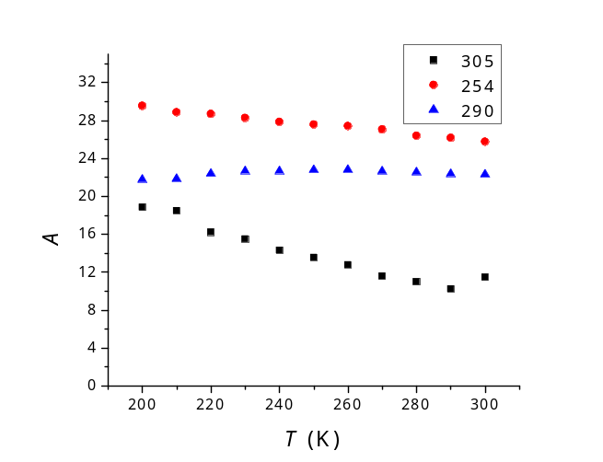

Figure ‎6.1: The values of A (i.e. the slope of lnI versus V at forward bias, equation 1.19) as a function of T for the samples described in Table ‎6.1

Further evidence of this mechanism is that the diode factor (n) decreased with T, as shown in Table ‎6.2. For the case of multi-step tunnelling it is this dependence that is an indicator of the mechanism, rather than the absolute value of n at any given T. Moreover, testing for the temperature dependence of J₀ versus T (equation 2.21) by plotting ln J₀ versus T as shown in Figure ‎6.2 gave a linear fits as expected.
Having established that the data conform to the case of multi-step tunnelling as described by equations 2.20 and 2.21, it is therefore appropriate to extract the number of tunnelling steps (R) for this process, as described in Section 2.5.2.

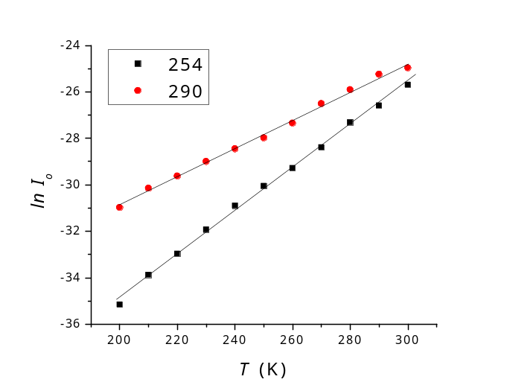

Figure ‎6.2: The linear relationship between lnI₀ and T for samples 254 and 290.

In order to obtain the value of R, both and K were needed to be calculated from equations 2.23 and 2.24 respectively. However, equation 2.24 implies that if the doping concentration in the CdS is considerably higher than that of the CdTe (i.e. N_{D} >> N_{A}), then K 1. This approximation has been used for CdTe/CdS cells by both Ercelebi et al. [5] and Al-Allak et. at. [6]. Equation 2.23 requires the value of doping concentration of the CdTe in order to determine α . Consequently, C-V measurements (see Section 2.2 for a description of this test) were carried out in the dark at a frequency of 150 KHz. The resulting curves for samples 290 and 254 are shown in Figure ‎6.3.

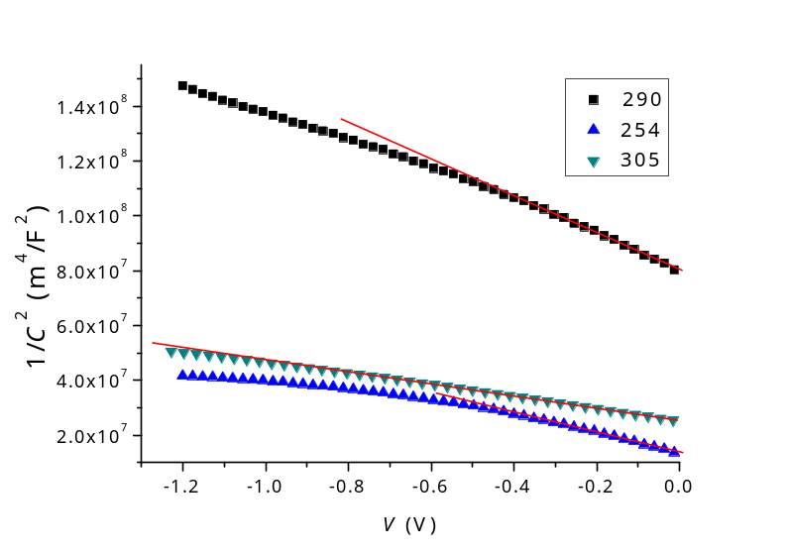

Figure ‎6.3: 1/C² versus reverse V for samples 254, 290 and 305. The lines show the linear fits of the data from which both the doping concentration near the junction (N_{A}) and the built-in potential V_{bi} were extracted.

Using both equation 2.7 and the linear parts in Figure ‎6.3, N_{A} was found to be 2.07 × 10¹⁵/cm³ and 5.36 × 10¹⁵/cm³ for samples 290 and 254 respectively. For the CdTe, the values of and m_{n} were chosen to be 10.36 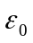 and 0.096 m_{e} respectively [7]. R values at room temperature were determined by using this information as shown in Table ‎6.3. These were of the same order of magnitude as the results found by Al-Allak et al. [6].

Sample | Doping/cm³ |  | Slope of  ln J vs. V, (A) | Number of tunnelling steps (R)
290 | 2.07×10¹⁵ | 462.91 | 22.29 | 432
254 | 5.36×10¹⁵ | 287.77 | 25.75 | 125

Table ‎6.3: Parameters extracted from samples 290 and 254 to determine the number of tunnelling steps R.

b) Sample 305 (with CdZnS window layer)
The analysis of J-V-T data for sample 305 was in accordance with the mechanism of recombination in the depletion region mechanism, which is described in Section 2.5.3. Contrary to samples 290 and 254, the constant A decreased with increasing T as illustrated in Figure ‎6.1, indicating that the transport mechanism is thermally activated. The ideality factor n was approximately 2 and was invariant with T as shown in Table ‎6.2, which is the ideal value for a depletion region dominated recombination current transport mechanism (see Section 2.5.3). Moreover, the temperature independent of n has been reported for CdTe/CdS cells in which the current transport was dominated by recombination processes [8, 9], (the mathematical origin of this value of n is discussed in Appendix B). Furthermore, Figure ‎6.4 shows that ln J₀ varied linearly with 1/T (equation 2.29) also suggesting this transport mechanism.

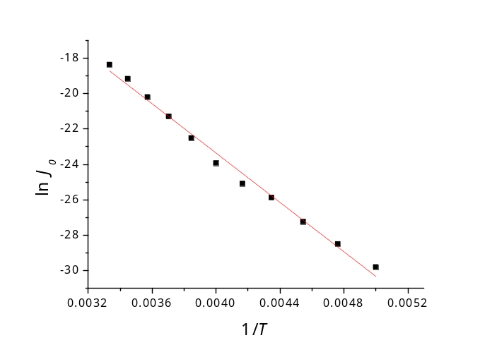
Figure ‎6.4: ln J_{o} versus 1/T for sample 305.

The light measurement in forward bias
The results extracted from the J-V curves under 100 % illumination (approximately 1000 Wm⁻² AM1.5), which were used to determine the built-in potential (V_{bi}) for the investigated devices are discussed first. V_{oc} is plotted as a function of T for all cells in Figure ‎6.5 in order to determine V_{bi} of the main junction (i.e. CdTe/CdS heterojunction) by using equation 2.39 as explained in Section 2.6.
The intercept of the of the resulted line with the V_{oc} axis (at T = 0), as shown in Figure ‎6.5, gives the built-in potential V_{bi}, which was found to be 1.26 V, 1.15 V and 1.19 V for samples 290, 254 and 305, respectively. It is seen in Figure ‎6.5 that below T ~ 230 K the data of samples 290 and 305 deviates from linearity which is attributed to carrier freeze-out [10].

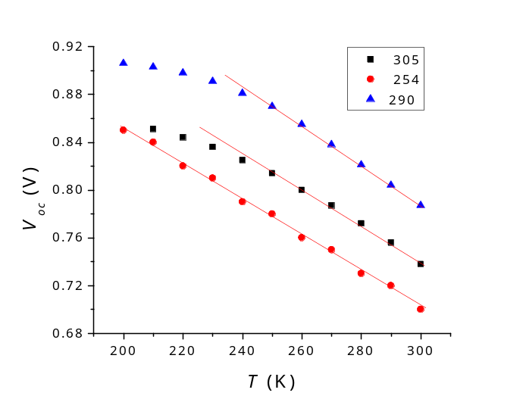
Figure ‎6.5: The V_{oc} for all samples as a function of T. The lines represent the straight parts which were extrapolated to the V_{oc} axis to determine the built-in potential.

The built-in potential for all samples was determined also from the C-V measurements (equation 2.7). Using the intercept values from Figure ‎6.3, V_{bi} was 1.2 V, 0.43 V and 1.12 V for samples 290, 254 and 305 respectively. Moreover, as recombination in depletion region was the most dominant current process for sample 305, V_{bi} for this cell may be measured from equation 2.30, by determining the activation energy (ΔE) using both equation 2.29 and Figure ‎6.4. ΔE was found to be 0.6 eV (and n ~ 2 as shown in Table ‎6.2), resulting in V_{bi} = 1.2 eV. The values of V_{bi} as determined from the different methods mentioned above are summarised in Table ‎6.4.

Sample | V_{bi} (eV)
Sample | V_{oc} vs. T method | C-V method | ΔE method
290 | 1.26 | 1.2 | -
254 | 1.15 | 0.43 | -
305 | 1.19 | 1.12 | 1.2

Table ‎6.4: V_{bi} values for all cells as extracted using different methods.

The values of the built-in potential determined by using the method described above (Table ‎6.4) are in a good agreement, with error (ratio between the average to SD) ~ 3 %, however, it is ~ 70 % for sample 254. The discrepancy in V_{bi} values for sample 254 may occur from the inaccuracy of the built-in potential value extracted from the C-V measurements. It has been reported that the C-V data could lead to erroneous results for the built-in potential values due to various reasons such as the localized states in the energy gap [11]. Therefore, V_{bi} extracted from Figure ‎6.5 (i.e. V_{oc} vs. T method) are used for calculations in following sections due to its higher accuracy compared to the results of the C-V measurements.
The current transport mechanism under forward bias and in the light is discussed now. Both I₀ and n were evaluated by using the slope method (for light data, see Section 2.4f). The results calculated for sample 254 using this method are resented in Table ‎6.5.

T (K) | I_{o} (A) | n
300 | 2.18E-06 | 3.8
290 | 2.12E-06 | 4
280 | 3.98E-06 | 4.8
270 | 6.361E-06 | 5.5
260 | 4.61E-06 | 5.4
250 | 6.2E-06 | 6.1
240 | 1.14E-05 | 7.2
230 | 1.54E-05 | 8.1
220 | 2.15E-05 | 9.2
210 | 4.71E-05 | 11.9
200 | 5.25E-05 | 13

Table ‎6.5: The values of both saturation current and ideality factor for sample 254 (under AM1.5 illumination) as extracted form equation 1.9.

The n values determined by the method described above varied in the range 3.8 (300K) to 13 (200K) even though n is only expected to have a physical meaning in the range 1  n  2 [12]. The physical meaning of n is discussed in both Section 2.4 and Appendix B.
Illumination can make dramatic changes to the shape of the J-V curve of solar cells. For example, the superposition principle is known to be invalid for CdTe/CdS cells, which means that the behaviour of the J-V curve varies under light in comparison to that in dark [13, 14]. The light absorbed in the CdS layer was reported to cause steeper J-V characteristics than the dark ones due to ionisation of deep traps in the CdS [15]. The non-ideal behaviour of the illuminated J-V curve affects the values of both slope and intercept extracted by using equation 2.9. Hence, the method used to determine n and I₀ in dark (i.e. the slope method) is not reliable to analyse data collected under illumination. The illuminated data, therefore, were analysed by considering the new method described in Section 2.5.4, which revealed that SRH recombination is operating for all cells under both forward bias and illumination.
Figure ‎6.6- Figure ‎6.8 show the plots of equation 2.38 at various light intensities for samples 290, 254 and 305 respectively. The results of these plots are summarized in Table ‎6.6 - Table ‎6.8 respectively.

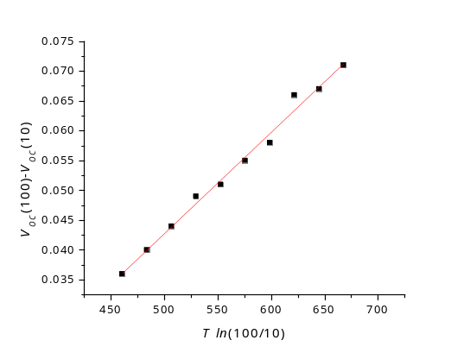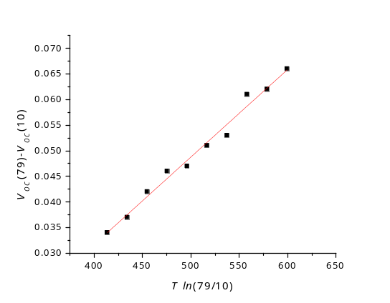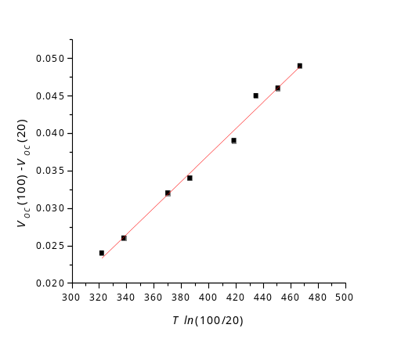

Figure ‎6.6: 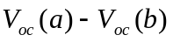versus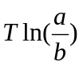according to equation 2.38 for sample 290. In each figure the light relative intensity used are shown in the y-axis.

Light intensities | Slope (V/K) | n
100 % to 10 % | 1.69E-4 | 1.96
100 % to 20 % | 1.76E-4 | 2.04
79 % to 10 % | 1.71E-4 | 1.98
Average of n values |  | 1.99
SD of n values |  | 0.04

Table ‎6.6: Slopes of Figure ‎6.6 and the calculated values of n for 290. The table shows also the average and the standard deviation of n values.

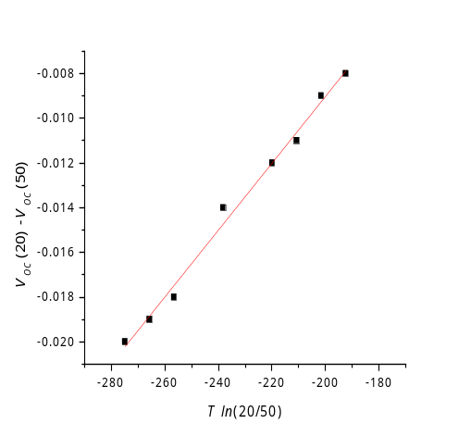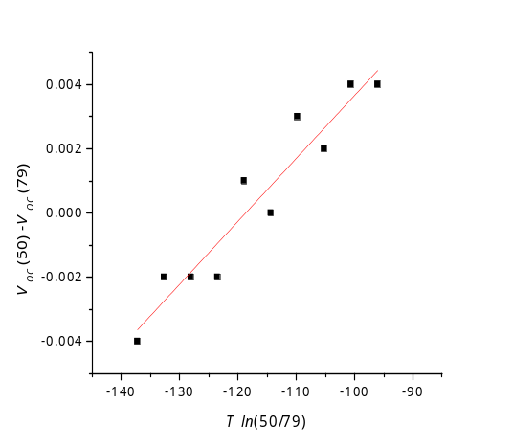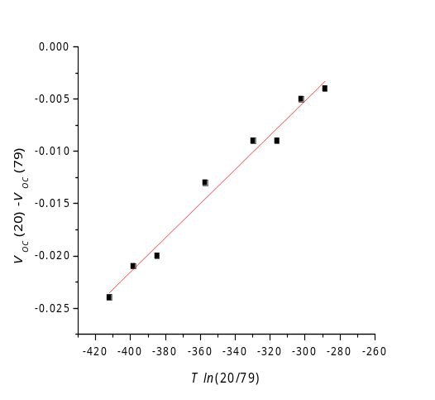

Figure ‎6.7: versusaccording to equation 2.38 for sample 254. In each figure the light relative intensity used are shown in the y-axis.

Light intensities | Slope (V/K) | n
20 % to 50 % | 1.49E-04 | 1.73
50 % to 79 % | 1.96E-04 | 2.27
20 % to 79 % | 1.63E-04 | 1.89
Average of n values |  | 1.96
SD of n values |  | 0.28

Table ‎6.7: Slopes of Figure ‎6.7 and the calculated values of n for 254. The table shows also the average and the standard deviation of n values.

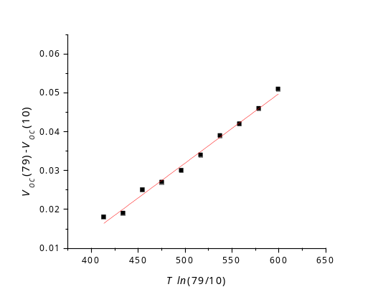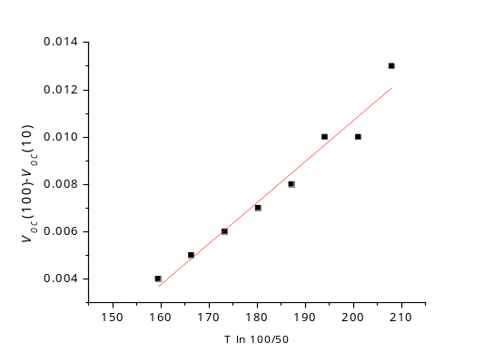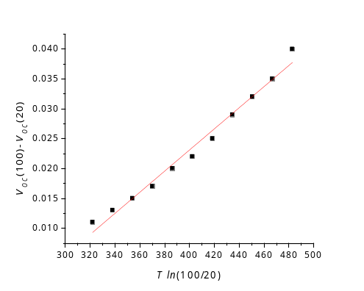

Figure ‎6.8: versusaccording to equation 2.38 for sample 305. In each figure the light relative intensity used are shown in the y-axis.

Light intensities | Slope (V/K) | n
100 % to 50 % | 1.73E-4 | 2
79 % to 10 % | 1.79E-4 | 2.07
100 % to 20 % | 1.76E-4 | 2.04
Average of n values |  | 2.04
SD of n values |  | 0.04

Table ‎6.8: Slopes of Figure ‎6.8 and the calculated values of n for 305. The table shows also the average and the standard deviation of n values.

Table ‎6.6- Table ‎6.8 show that n ~ 2 for all samples. It can be concluded, therefore, that SRH recombination is the most probable transport mechanism in the forward bias under illumination as explained in Section 2.5.4. This mechanism has been reported for CdTe/CdS cells by both Oman et al. [10, 16] and Hegedus and McCandless [10].
The reason of having a different transport mechanism under illumination (compared to the dominating mechanisms in the dark) could be attributed to the light-induced changes in the material. For example, it has been reported that illumination had a significant effect on the interface states for CdTe/CdS cells [17]. The photogenerated carriers fill the interface states which may lead to different electrical behaviour in the CdTe/CdS junction.

The dark measurement in reverse bias
Multi-step tunnelling process was found to dominate the current flow under reverse bias in the dark for all cells based on the analysis of their J-V-T characteristics. The relationship between J_{r} and V under reverse bias was investigated by testing the power dependence of I_{r} on V using equation 2.28 (see Section 2.5.2b). The power values (m) (from equation 2.28) as a function of T for all samples are summarised in Table ‎6.9.

m values
T | Sample 305 | Sample 245 | Sample 290
300 | 1.08 | 1.21 | 1.08
290 | 1.10 | 1.30 | 1.00
280 | 1.11 | 1.44 | 1.02
270 | 1.13 | 1.79 | 1.05
260 | 1.15 | 2 | 1.02
250 | 1.18 | 2.24 | 1.02
240 | 1.21 | 2.36 | 1.03
230 | 1.29 | 2.57 | 1.04
220 | 1.29 | 2.27 | 1.07
210 | 1.33 | 2.44 | 1.11
200 | 1.40 | 2.80 | 1.16

Table ‎6.9: The values of m (the slope of lnI_{r} versus lnV , equation 2.28) at all temperatures tested in this experiment.

As seen in the table, m generally decreased as T increased. This behaviour has been reported for tunnelling dominated transport mechanism by Yakubu [18] and Vatavu and GaSin [19] for CdTe/ITO and CdTe/CdS devices respectively.
Additionally, data of all cells conformed equation 2.27, which is another evidence of the domination of multi-step tunnelling mechanism on current transport. The values of the built-in potential V_{bi} extracted from Figure ‎6.5 (i.e. V_{oc} vs. T) were used in this calculation. Figure ‎6.9 - Figure ‎6.11 show the ln (J_{r}/V) against (V_{bi} - V)^{-1/2} plots at T varied from 300 K to 200 K for samples 290, 254 and 305 respectively.

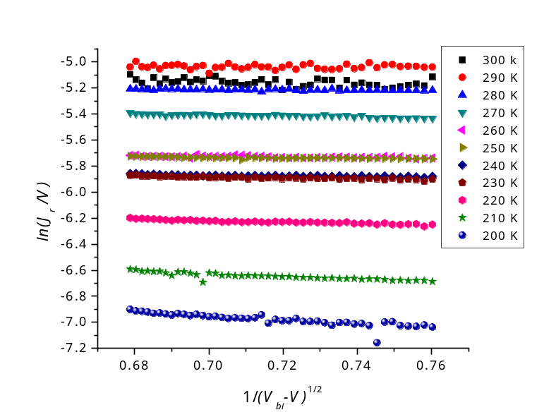

Figure ‎6.9: ln (J_{r}/V) vs. (V_{bi} - V)^{-1/2} for sample 290 at T = 300 – 200 K.

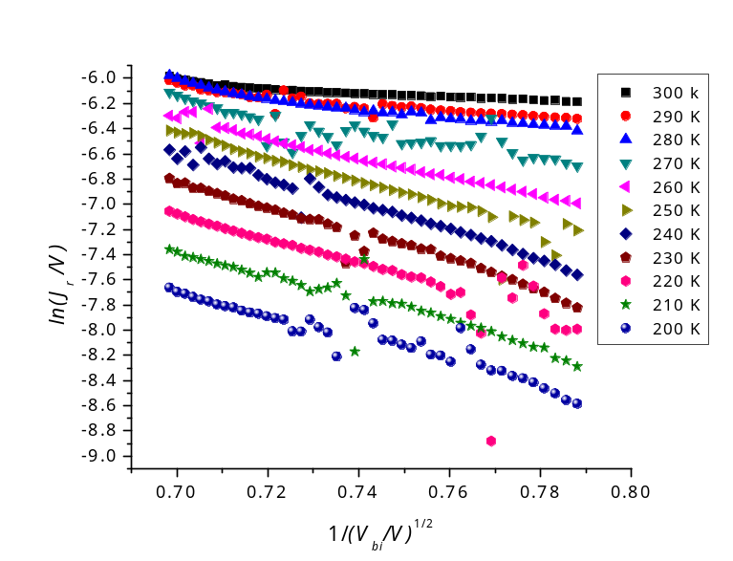

Figure ‎6.10: ln (J_{r}/V) vs. (V_{bi} - V)^{-1/2} for sample 254 at T = 300 – 200 K.

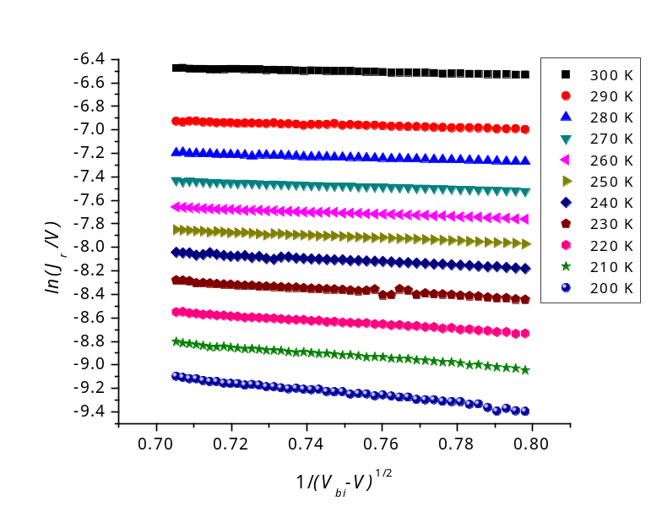

Figure ‎6.11: ln (J_{r}/V) vs. (V_{bi} - V)^{-1/2} for sample 305 at T = 300 – 200 K.

The slope and the intercept of each line in the figures above are summarized in Table ‎6.10. Figure ‎6.10 shows that the curves of sample 254 were noisier than those for other samples. However, its general behaviour is governed by equation 2.27.

T | Sample 290 |  | Sample 254 |  | Sample 305
T | slope | intercept | slope | intercept | slope | intercept
300 | -0.192 | -17.74 | -1.26 | -17.91 | -0.634 | -16.62
290 | -0.0198 | -17.74 | -2.7 | -16.91 | -0.798 | -16.96
280 | -0.153 | -17.82 | -4.611 | -15.57 | -0.799 | -17.23
270 | -0.454 | -17.81 | -7.883 | -13.19 | -0.857 | -17.43
260 | -0.164 | -18.33 | -8.615 | -13 | -0.957 | -17.59
250 | -0.211 | -18.3 | -9.147 | -12.77 | -1.169 | -17.63
240 | -0.278 | -18.39 | -9.966 | -12.34 | -1.284 | -17.74
230 | -0.363 | -18.35 | -10.45 | -12.23 | -1.447 | -17.87
220 | -0.58 | -18.53 | -9.135 | -13.42 | -1.741 | -17.93
210 | -0.963 | -18.67 | -11.356 | -12 | -2.119 | -17.93
200 | -1.428 | -18.67 | -7.699 | -15.06 | -2.678 | -17.83

Table ‎6.10: The values of slopes and intercepts extracted from Figure ‎6.9 - Figure ‎6.11.

Generally, slopes of all samples decreased as T increased. This behaviour was reported by Ercelebi et al. [5] and was attributed to the temperature dependence of band gap. However, it is seen in Table ‎6.10 that there is some inconsistency in this behaviour for some values such as the slopes of samples 290 and 254 at 290 K and 200 K respectively. This could arise from errors in measuring the slopes due to the scattering of the data.
Since the current transport obeyed multi-step tunnelling model under the reverse bias condition as discussed above, equation 2.27 beside intercept values in Table ‎6.10 were used to determine the trap density N_{t} as explained in Section 2.5.2b. The lattice constant (a) for the CdTe was chosen to be 6.48 Å [20]. N_{t} values for all samples at T varied from 300 K to 200 K are summarised in Table ‎6.11.
N_{t} values for samples 290 and 305 agree with those measured by Proskuryakov et al. [21] using admittance spectroscopy for CdTe:As/CdS cells. Proskuryakov reported that N_{t} was found to be ~ 10¹⁴/cm³ and 10¹⁵/cm³ for shallow and deep traps respectively. Furthermore, Al-Amri [22] used the space charge limited current (SCLC) theory to calculate N_{t} as a function of T (which varied in a range of ~ 220 – 330 K) for both CdCl₂-treated and untreated cells. All results were found to be in the same order of magnitude (10¹⁴/cm³) with higher values for the untreated cells. Therefore, the slight increase in the values of N_{t} for samples 305 and 290 compared to those reported by Al-Amri may arise from the insufficient CdCl₂ treatment for devices investigated in this work, which may lead to relatively higher values of the trap density. N_{t} values for sample 254 varied with T inconsistently as seen in Table ‎6.11. This behaviour can be attributed to errors in calculations arising from scatter of data in Figure ‎6.10.

N_{t} (cm⁻³)
T (K) | Sample 290 | Sample 254 | Sample 305
300 | 1.84E+15 | 2.19E+15 | 6.06E+14
290 | 1.85E+15 | 8.09E+14 | 8.45E+14
280 | 2.01E+15 | 2.1E+14 | 1.11E+15
270 | 1.98E+15 | 1.96E+13 | 1.36E+15
260 | 3.33E+15 | 1.62E+13 | 1.59E+15
250 | 3.25E+15 | 1.28E+13 | 1.66E+15
240 | 3.55E+15 | 8.33E+12 | 1.86E+15
230 | 3.4E+15 | 7.46E+12 | 2.12E+15
220 | 4.08E+15 | 2.46E+13 | 2.24E+15
210 | 4.7E+15 | 5.94E+12 | 2.23E+15
200 | 4.68E+15 | 1.27E+14 | 2.02E+15

Table ‎6.11: Trap density (N_{t}) of all samples in the whole range of T used in the study.

It can be concluded that multi-step tunnelling is the most dominant transport mechanism for dark reverse current for all samples investigated in this study. This transport process has been reported by several studies to be the dominant transport mechanism for CdTe/CdS solar cells under reverse bias condition [5, 17, 19, 23].

Conclusion
The electrical current flow process in CdTe heterojunction solar cells was investigated for three different devices. The transport mechanisms were studied in both forward and reverse biases, with and without illumination.
Multi-step tunnelling mechanism was found to the dominate process in the dark forward current for CdTe/CdS cells fully grown by either CSS or MOCVD. However, the current transport for the MOCVD-CdTe/CdZnS cell was governed by recombination in depletion region. In other words, the transport mechanism in the dark forward bias seems to be dependent on the type of the window layer rather than the growth technique.
It is important to point out that the method used to extract the ideality factor values in dark was not capable to give reasonable results for experiment undertaken under light. Therefore, the transport mechanism under illumination was investigated by considering a new method, which relies on the behaviour in the V_{oc} as a function of T in two different light intensities.
For measurements carried out under illumination, SRH recombination was the most probable mechanism for all samples. Light-induced changes in the materials were speculated to be responsible of the transformation of the transport mechanisms between dark and light.
In case of the reverse bias, multi-step tunnelling was again dominating the flow of carriers for all the devices investigated in this Chapter. The transport mechanism in the reverse bias was independent on both a) the growth techniques by which the devices were fabricated, and b) the window layer type.
By using the multi-step tunnelling model, it was possible to measure a) the number of the required tunnelling steps to traverse the junction under forward bias conditions, which was found to be 432 and 125 steps for samples 290 and 254 respectively. These values are comparable to what Al-Allak et al. [6] reported for CdTe/CdS cells, which was 294 steps. b) the trap density in the reverse bias, which was ~ 10¹⁵ cm⁻³ for samples 290 and 305. The values agree with that reported by Proskuryakov et al. [21], and one order of magnitude higher that Al-Amri’s results [22], which may be attributed to the CdCl₂ treatment. Both recombination and tunnelling processes require a high density of localised levels. Those levels can result from the mismatch between the CdTe and the window layers, which is 10.8 % in the case of CdTe/CdS heterojunction [24]. The lattice mismatch can be increased by the different thermal expansion coefficients of CdTe and window layer materials [25].
The reverse bias measurements in light were not analysed in this work because of the high noise in the data. Light generated current J_{L} is greatly higher than the saturation current J₀, and therefore, any disruption in the J_{L} could dominate the whole reverse current in light. The noise could be generated form flickering of the light source in the solar simulator. Moreover, J_{L} cannot be directly extracted from the whole reverse current under light due to the invalidity of the superposition principle for the studied devices, which is beyond the scope of this thesis. To the author’s knowledge, there is no published work regarding the analysis of the reverse light current in the literature.

- References for Chapter 5

[1] Y. Raviprakash, K. V. Bangera and G. K. Shivakumar, Current Applied Physics 10 (2010) 193-198.
[2] P. Kumar, A. Misra, D. Kumar, N. Dhama, T. P. Sharma and P. N. Dixit, Optical Materials 27 (2004) 261-264.
[3] S. V. Borse, S. D. Chavhan and R. Sharma, Journal of Alloys and Compounds 436 (2007) 407-414.
[4] V. Barrioz, Y. Y. Proskuryakov, E. W. Jones, J. D. Major, S. J.C. Irvine, K. Durose and D. A. Lamb, in Materials Research Society, Spring meeting, Symposium Y, San Francisco, CA, USA, (2007), 1012, 367-372.
[5] C. Ercelebi, A. W. Brinkman, T. S. Furlong and J. Woods, Journal of Crystal Growth 101 (1990) 162-166.
[6] H. M. Al-Allak, A. W. Brinkman, H. Richter and D. Bonnet, Journal of Crystal Growth 159 (1996) 910-915.
[7] A. W. Brinkman. in (Capper, P., Ed.) Properties of Narrow Gap Cadmium-based Compounds, INSPEC, the Institution of Electrical Engineers, London (1994).
[8] K. W. Mitchell, Evaluation of the CdS/CdTe Heterojunction Solar Cell, Garland Publishing, Inc., New York, (1979).
[9] H. Bayhan and C. Ercelebi, Semiconductor Science and Technology 12 (1997) 600-608.
[10] S. S. Hegedus and B. E. McCandless, Solar Energy Materials and Solar Cells 88 (2005) 75-95.
[11] A. A. Alnajjar, M. F. A. Alias, R. A. Almatuk and A. A. J. Al-Douri, Renewable Energy 34 (2009) 2160-2163.
[12] S. M. Sze, Physics of Semiconductor Devices, 2nd ed., A Wiley-Interscience Publication, New Jersey, (1981).
[13] T. J. McMahon and A. L. Fahrenbruch, in Photovoltaic Specialists Conference, 2000. Conference Record of the Twenty-Eighth IEEE, Anchorage, AK, USA, (2000), 539-542.
[14] D. L. Linam, V. P. Singh, J. C. McClure, G. B. Lush, X. Mathew and P. J. Sebastian, Solar Energy Materials and Solar Cells 70 (2001) 335-344.
[15] M. Köntges, R. Reineke-Koch, P. Nollet, J. Beier, R. Schäffler and J. Parisi, Thin Solid Films 403-404 (2002) 280-286.
[16] D. M. Oman, K. M. Dugan, J. L. Killian, V. Ceekala, C. S. Ferekides and D. L. Morel, Solar Energy Materials and Solar Cells 58 (1999) 361-373.
[17] T. L. Chu, S. S. Chu and S. T. Ang, Journal of Applied Physics 64 (1988) 1233-1237.
[18] H. Yakubu, Renewable Energy 17 (1999) 61-71.
[19] S. Vatavu and P. GaSin, Thin Solid Films 515 (2007) 6179-6183.
[20] L. I. Berger and B. R. Pamplin. in (D. R. Lide and H. P. R. Frederikes, eds.) CRC Press LLC (1997-1998).
[21] Y. Y. Proskuryakov, K. Durose, J. D. Major, M. K. Al Turkestani, V. Barrioz, S. J. C. Irvine and E. W. Jones, Solar Energy Materials and Solar Cells 93 (2009) 1572-1581.
[22] S. N. A. Alamri, PhD Thesis, Durham University, Durham, (1999).
[23] S. S. Ou, O. M. Stafsudd and B. M. Basol, Solid-State Electronics 27 (1984) 21-25.
[24] K. Vamsi Krishna and V. Dutta, Thin Solid Films 450 (2004) 255-260.
[25] A. Romeo, D. L. Bätzner, H. Zogg and A. N. Tiwari, Thin Solid Films 361-362 (2000) 420-425.

